

**LEVEL: 3**

**STREAM: A**

|  |  |
| --- | --- |
| **NAMES** | **REG NUMBER** |
| **HIRWA** | **Cherubin** |
| **IINGABIRE** | **Appolonie** |

**MINI PROJECT**

**MONITORING THE TEMPERATURE AND HUMIDITY IN THE GARDEN THROUGH GSM.**

**MONITORING THE TEMPERATURE AND HUMIDITY IN THE GARDEN THROUGH GSM.**

**Abstract**

The world is moving at a such rapid rate that we need to move with technology to facilitate things.

This project of monitoring the temperature and humidity of the garden using GSM notification came as the solution for garden because it can’t grow well under hot and humid condition[1]. The temperature and humidity sensor will measure the environmental conditions and will be processed by a microcontroller and after detecting the condition of the garden and sends the SMS notification via the phone. Actually garden is composed with flowers that’s why we need to monitor the high temperature and humidity, this will allow you to control the transpiration rate of the garden keeping it at an optimal level. The main purpose of this project is to make a smart garden which will use the automation technology in management of electronic devices for convenient viewing of conditions measured by monitors and sensors in multiple areas inside and outside of the home.

**Problem statement**

Garden makes a place look beautiful that’s why we need to take care by monitoring the temperature and humidity. Monitoring is beneficial for garden because changes in the growing environment can be dealt with before they damage garden[2]. This means that harsh conditions and losses due to problems such as sudden temperature fluctuations are quickly identified, and adjustments can be made to avoid widespread flowers losses. unsuitable soil temperature can be detrimental to the successful planting of the garden and just because the garden soil temperature has warmed up enough don’t assume that the garden is safe.we want our garden to grow big with good healthy.

**Block diagram + description**

1. **DHT 22:** for humidity and temperature sensing and give the result of temperature in Celsius and for humidity it provide the result in percentage.
2. Arduino Uno: for converting the resistance measurement to relative humidity and temperature and also stores calibration coefficient.
3. Resistor: for protecting the DHT22 .
4. GSM MODULE 900A: this is the module where we insert the sim card inside for sending SMS the notification

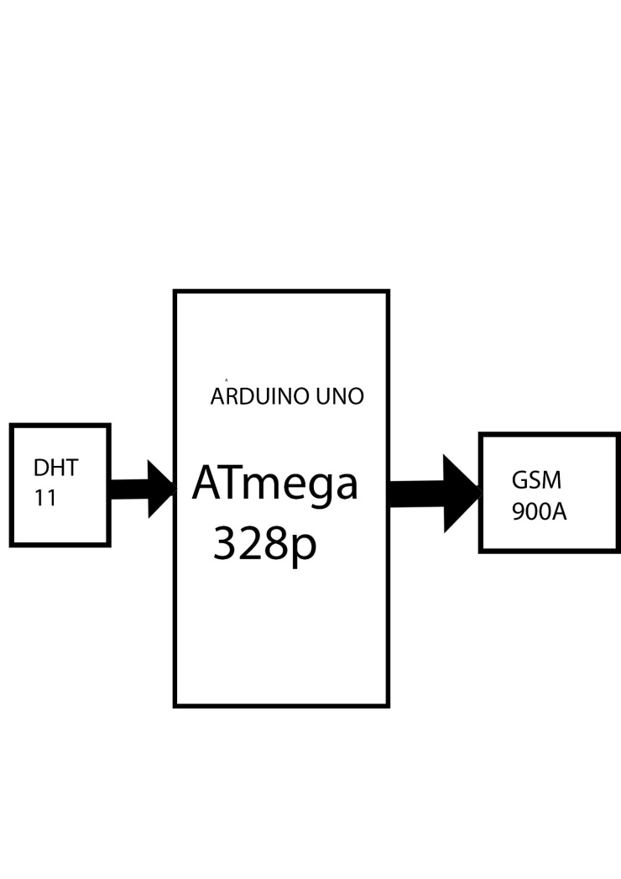

**Circuit diagram**

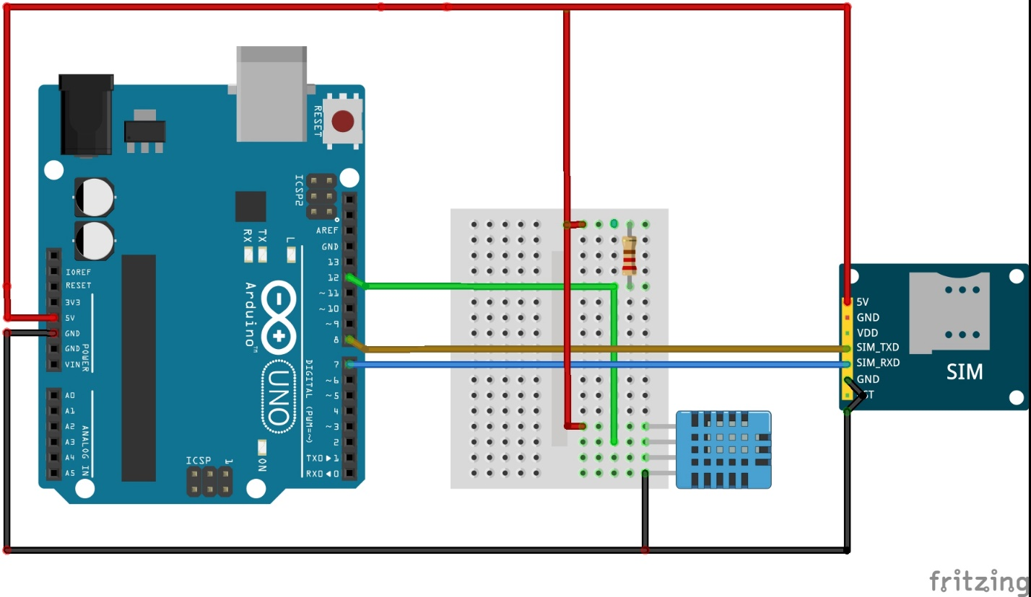

**Simulation in proteus**

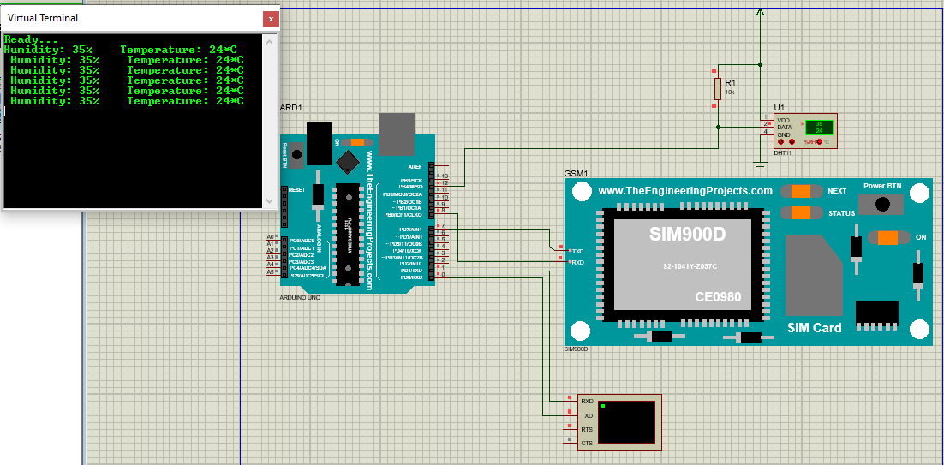

[1] R. R. Shamshiri, J. W. Jones, K. R. Thorp, D. Ahmad, H. C. Man, and S. Taheri, “Review of optimum temperature, humidity, and vapour pressure deficit for microclimate evaluation and control in greenhouse cultivation of tomato: A review,” *International Agrophysics*, vol. 32, no. 2. Walter de Gruyter GmbH, pp. 287–302, Apr. 01, 2018. doi: 10.1515/intag-2017-0005.

[2] A. Sumarudin, A. L. Ghozali, A. Hasyim, and A. Effendi, “Implementation monitoring temperature, humidity and mositure soil based on wireless sensor network for e-agriculture technology,” in *IOP Conference Series: Materials Science and Engineering*, May 2016, vol. 128, no. 1. doi: 10.1088/1757-899X/128/1/012044.